Stock Price Prediction Assistant using Machine Learning
Designed for: Second-year students
M.AjayKumar-2403A52378
L.Manogn Reddy-2403A52388
G.Sanjana-2403A52380
Domain: Finance — Stock Price Prediction
Contents
- Overview
- General steps (adapted for stock prediction)
- Example pipeline & code snippets
- Model choices and evaluation
- Feature engineering & technical indicators
- Backtesting and risk considerations
- Deployment (demo app) and explainability
- Project timeline & assessment rubric
- Student deliverables & submission checklist
- Ethical and practical notes

1. Project Overview
Problem: Build a Stock Price Prediction Assistant that accepts a ticker symbol and historical market data and outputs short- to medium-term price forecasts, buy/hold/sell suggestions (with confidence scores), and simple explanations for the prediction.
Objective: Implement an end-to-end ML pipeline that downloads/loads financial data, engineers features (technical indicators), trains predictive models (classical ML and sequence models), evaluates performance with proper backtesting, and exposes a small demo UI (Streamlit or Flask).
Inputs: Ticker symbol, time range, optional fundamental data, optional custom feature parameters (window sizes).
Outputs: Predicted price (next day / next week / next N days), probability/confidence, suggested action (buy/hold/sell), relevant feature importance / explanation.

2. General Steps (Adapted)
Step 1 — Title & scope. - Title: Stock Price Prediction Assistant using Machine Learning. - Scope: choose one horizon (e.g., next-day close or 7-day return), 1–3 tickers (or a single stock index), and limit features to technical indicators + optionally fundamentals.
Step 2 — Data collection. - Sources: Yahoo Finance (yfinance), Alpha Vantage (free tier), Quandl, Kaggle datasets for historical stock prices. Ensure API key and rate limits are considered.
Step 3 — Environment setup. - Python 3.8+; virtualenv/conda. Install common libs: bash pip install pandas numpy scikit-learn matplotlib seaborn tensorflow keras xgboost ta shap yfinance streamlit
Step 4 — Data exploration & preprocessing. - Fetch OHLCV (open, high, low, close, volume). Check for missing days (non-trading days). Align timezones. Handle splits and dividends (adjusted close). - Visualize price, returns, volume, and correlations.
Step 5 — Feature engineering. - Add technical indicators (moving averages, RSI, MACD, Bollinger Bands, ATR, volume-based features). Create lag features and rolling statistics. - Create target: next-day return, next-day direction (classification), or multi-day return (regression).
Step 6 — Model selection & training. - Baselines: persistence model (price_t+1 = price_t), linear regression, logistic regression (for direction), RandomForest/XGBoost, and LSTM/GRU for sequences. - Use walk-forward validation / time-series cross-validation — avoid standard random train/test splits.
Step 7 — Evaluation & backtesting. - Regression metrics: RMSE, MAE, MAPE. Classification metrics (direction): accuracy, precision, recall, F1, Matthews correlation. - Backtest simple strategy (e.g., go long when model predicts positive return with prob > threshold) and compute cumulative returns, Sharpe ratio, max drawdown.
Step 8 — Explainability & AI-assisted code. - Use SHAP or feature_importances_ to explain model decisions. Document prompts/outputs if you use ChatGPT/Copilot for code.
Step 9 — Demo UI. - Build a Streamlit app: input ticker, date range, choose model, show predictions, plots, and simple trade simulator.
Step 10 — Documentation & submission. - README, requirements.txt, instructions, short report, and demo video (optional). Include a one-page note describing where AI assisted you and include prompts.

3. Example pipeline & code snippets
import yfinance as yf
import pandas as pd
import numpy as np
from sklearn.model_selection import train_test_split
from sklearn.preprocessing import MinMaxScaler
from sklearn.ensemble import RandomForestClassifier
from sklearn.metrics import accuracy_score, classification_report
from tensorflow.keras.models import Sequential
from tensorflow.keras.layers import Dense, LSTM
import matplotlib.pyplot as plt

def load_stock(ticker="AAPL", start="2015-01-01"):
df = yf.download(ticker, start=start, auto_adjust=True, progress=False)
df.dropna(inplace=True)
return df

df = load_stock("AAPL")
print("Data Loaded Successfully\n", df.head())

df["Return"] = df["Close"].pct_change()
df["Target"] = (df["Return"].shift(-1) > 0).astype(int)
df.dropna(inplace=True)

features = ["Open", "High", "Low", "Close", "Volume", "Return"]
X = df[features].values
y = df["Target"].values

split = int(len(X) * 0.8)
X_train_RF, X_test_RF = X[:split], X[split:]
y_train_RF, y_test_RF = y[:split], y[split:]

rf = RandomForestClassifier(n_estimators=200, random_state=42)
rf.fit(X_train_RF, y_train_RF)

rf_pred = rf.predict(X_test_RF)
print("\nRANDOM FOREST RESULTS:")
print("Accuracy:", accuracy_score(y_test_RF, rf_pred))
print(classification_report(y_test_RF, rf_pred))

scaler = MinMaxScaler()
scaled = scaler.fit_transform(df[["Close"]])

def make_sequences(data, seq_len=50):
X, y = [], []
for i in range(len(data) - seq_len):
X.append(data[i:i+seq_len])
y.append(data[i+seq_len])
return np.array(X), np.array(y)

seq_length = 50
X_seq, y_seq = make_sequences(scaled, seq_length)

split2 = int(len(X_seq) * 0.8)
X_train_LSTM, X_test_LSTM = X_seq[:split2], X_seq[split2:]
y_train_LSTM, y_test_LSTM = y_seq[:split2], y_seq[split2:]

model = Sequential([
LSTM(64, return_sequences=False, input_shape=(X_train_LSTM.shape[1], X_train_LSTM.shape[2])),
Dense(1)
])
model.compile(optimizer='adam', loss='mse')
model.fit(X_train_LSTM, y_train_LSTM, epochs=10, batch_size=32, verbose=1)

predicted = model.predict(X_test_LSTM)
predicted_prices = scaler.inverse_transform(predicted)
real_prices = scaler.inverse_transform(y_test_LSTM)

plt.figure(figsize=(10,5))
plt.plot(real_prices[:200], label="Actual Price")
plt.plot(predicted_prices[:200], label="Predicted Price")
plt.title("Stock Price Prediction (LSTM)")
plt.legend()
plt.show()

last_sequence = scaled[-seq_length:]
last_sequence = np.expand_dims(last_sequence, axis=0)

next_price_scaled = model.predict(last_sequence)
next_price = scaler.inverse_transform(next_price_scaled)

print(f"\nPredicted Next Close Price: ${next_price[0][0]:.2f}")

direction = rf.predict([df[features].iloc[-1].values])

if direction == 1:
print("Market Expected to Go: UP")
else:
print("Market Expected to Go: DOWN")

OUTPUTS
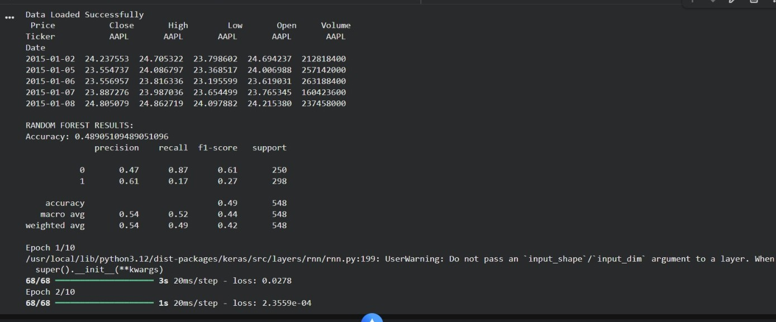

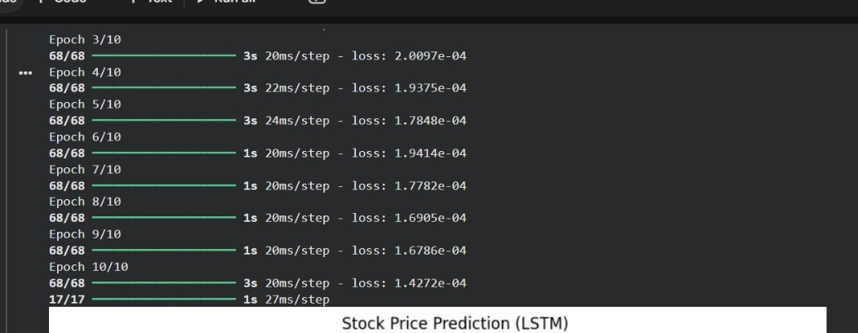
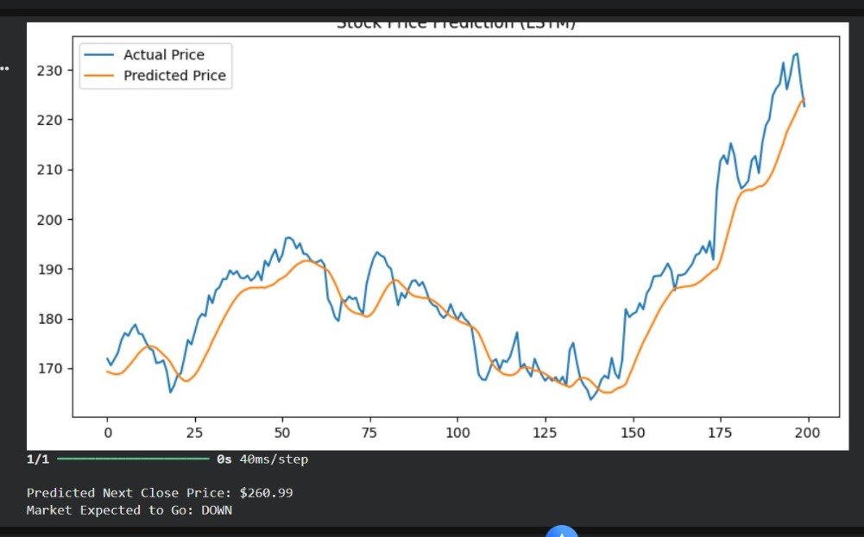

4. Model choices & evaluation details
Baselines: - Persistence model (naive): next return = last return. - Simple moving-average crossover rule for trading.
Machine learning models: - Tree-based: RandomForest, XGBoost, LightGBM — work well on tabular features. - Linear models: LinearRegression, Ridge — good baseline. - Sequence models: LSTM, GRU, 1D-CNN — for learning patterns in sequences.
Validation: - Always use time-aware validation (walk-forward), not random splits.
Metrics: - Regression: RMSE, MAE, MAPE. - Classification (direction): accuracy, precision, recall, F1, ROC-AUC. - Economic metrics from backtesting: cumulative returns, annualized return, Sharpe ratio, max drawdown.

5. Feature engineering & technical indicators
Common indicators to compute (use ta or implement manually): - Moving averages (SMA, EMA) with different windows (5, 10, 20, 50, 200) - MACD (12,26,9) - RSI (14) - Bollinger Bands (20, 2) - ATR (14) - On-balance volume (OBV) - Volume EMA, volume change - Lagged returns, rolling std (volatility), skewness, kurtosis over windows
Feature scaling and encoding: - Tree models do not require scaling; neural nets do (StandardScaler / MinMaxScaler).

6. Backtesting & risk considerations
- Implement a simple backtester: generate signals, apply position sizing, simulate transaction costs and slippage, and compute P&L.
- Consider transaction costs (e.g., 0.05% per trade) and slippage.
- Avoid lookahead bias: ensure features at time t only use data available at or before t.
- Walk-forward backtesting: retrain model periodically (e.g., monthly) and test on future window.

7. Deployment & explainability
Demo UI (Streamlit suggestions): - Inputs: ticker, start/end, prediction horizon, model selection, retrain toggle. - Outputs: price chart with predicted points, feature importance plot, backtest P&L plot, download button for predictions.
Explainability: - Use SHAP to show per-prediction explanations. - Present plain-language summaries (e.g., “Model predicts up day with 62% confidence — driven by rising RSI and positive momentum”).

8. Project Timeline & Assessment Rubric (Suggested 4-week plan)
Week 1: Proposal, dataset selection, environment set-up, initial EDA.
Week 2: Feature engineering and baseline models (persistence, linear models).
Week 3: Advanced models (XGBoost / LSTM), walk-forward validation, backtesting.
Week 4: UI, explainability, documentation, report, and presentation.
Rubric (100 marks): - Proposal & Dataset (10) - Code & Implementation (30) - Model & Evaluation (25) - UI & Demo (15) - Report & Presentation (15)

9. Student Deliverables & Submission Checklist
- Project proposal (1–2 pages) describing problem, scope, and dataset.
- Source code: notebooks + scripts, with requirements.txt and clear README.
- Dataset or data-loading instructions (API keys if needed) and data usage notes.
- Short report (3–5 pages) with methodology, results, and limitations.
- Streamlit/Flask demo or short demo video (optional).
- Presentation slides (5–10 slides).
- One-page note describing where AI (ChatGPT/Copilot) was used; include prompts and generated outputs.

10. Ethical & Practical Notes
- Data privacy & licensing: Only use publicly available market data or licensed datasets. Do not publish private broker data.
- Responsible AI: This is an educational tool — not financial advice. Include a disclaimer in the README and report.
- Reproducibility: Fix random seeds, include requirements.txt, and document how to run experiments.

